Basic Electronics Lab
Lab 0, 2nd August 2018
Aravind Reddy V (IMT 2015 524)
Krishna Nagaraja (IMT 2015 512)
_____________________________________________________________________________________

Gnuplot
Make sure to save as rollnumber.PDF
Some notes here. Optional. For example, the frequency and resistors used, and so on. Insert page breaks between each section. It’s in the Insert tab for Excel.
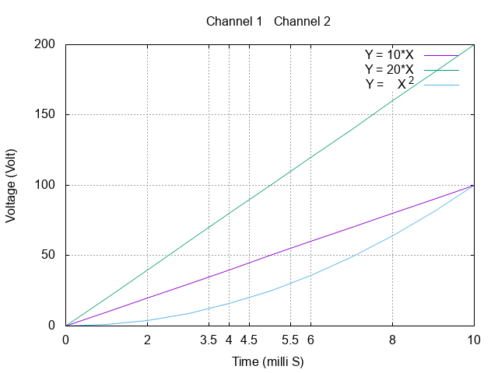

IV Characteristics of Resistor

Resistor used: 1 Kilo Ohm

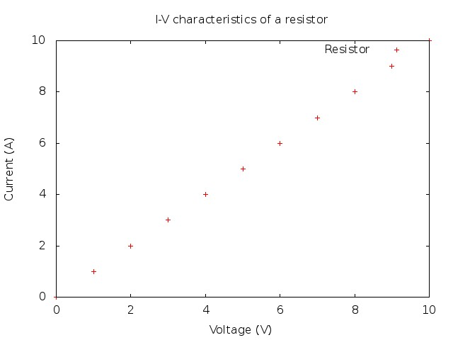

Diodes: Full wave rectifier

This is a simulation experiment. You’ll be simulating circuits in Multisim soon. I think I stole the circuit from a lab pdf. Circuit is mandatory in simulation experiments, but it would be helpful to include it in other experiments, too!
Circuit:
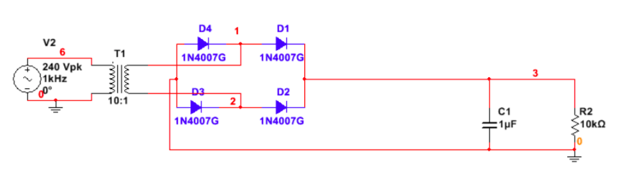
Graph:
